For booklets distributed at Pennsic 45 (Summer 2016), please replace the image in the middle of page 11 with the below image:

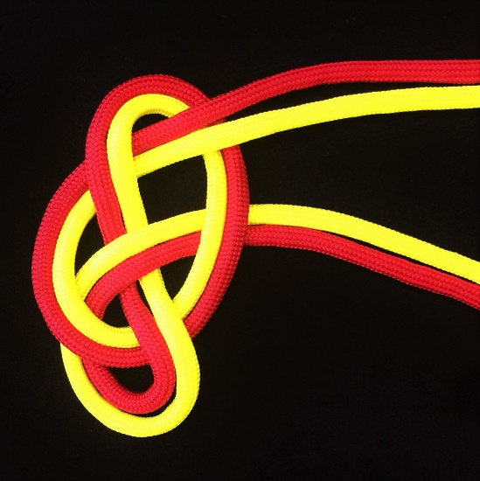
B
A
colors
match

