^{June 27, 2016}
Warping and Weaving on the Warp Weighted Loom
A brief history
The warp-weighted loom was the primary method of weaving fabric for clothing from prehistoric times, throughout classical antiquity, and in the early middle ages. Penelope was undoubtedly using a warp-weighted loom to weave the funeral cloth for Ulysses which she unwove every night to delay her suitors as she waited for his return. The Vikings were particularly skilled weavers, making complex fabrics like twill and the piled “rya” cloaks with tablet woven borders. By the 12th C it was being replaced by horizontal looms in much of Europe, but persisted into the 18th C in Norway and the 20th C among the Sami. In this more recent time period, the use of the warp-weighted loom was almost exclusively for coverlets, usually in weft-faced tabby and sometimes incorporating complex patterns.
The chief advantages of the warp-weighted loom are the small footprint which allows it to fit into a cramped dwelling, as well as the simplicity of design and smaller amount of wood required to build the loom. These features probably explain the persistence of the warp-weighted loom in the far North, especially among the Sami. The warp-weighted loom is slower than the horizontal loom for weaving plain fabrics, but for detailed woven in patterns much of the advantage in speed is lost, explaining why it continued in use for tapestries and coverlets long after it ceased to be used for making yardage.
Because the finished fabric is wound around the beam at the top, the weaver using a warp-weighted loom must work from the top down rather than from the bottom up and must beat upwards to pack the weft in place. It is important to have a sturdy starting border at the top which can be sewn to the beam assuring that no threads are pulled out by the weights hanging from them. It is thought that the Norse used a tablet woven starting border. One warp of this type, ready to attach to the loom for weaving was found in a pre-Viking Scandinavian site, and some fragments of Viking era cloth show evidence of such a starting border. The Sami use a rigid heddle to weave the starting border, and the later period Norwegians arrange the warp threads over a braided cord which is then sewn to the beam.
The weights were usually stone or fired clay and a number of them from different cultures have been preserved. Since the weights move while weaving they must have a sturdy hole or loop for attaching them to the warp threads. It is helpful if all the weights used for a given project are approximately equal so that they can each be tied to the same number of warp threads. The size and shape of the weights depend on the culture and the type of cloth being woven. For a full size Norse or Icelandic loom they need to weigh in the range of 500kg, or more if making a fairly coarse woven piece such as a coverlet.
The Norse version of the warp-weighted loom is not truly vertical but is at an angle so the shed rod can hold half the warp threads in front while the remaining threads hang straight down, leaving a shed space for the weaver to pass the shuttle. For tabby, only one rod with heddles is needed to pull the back threads forward opening the opposite shed. For twill, three heddle rods plus the shed bar offer 4 different combinations of threads equivalent to a 4 harness loom. For the Norse or Icelandic warp-weighted loom heddles are tied onto the rod. Traditionally this is done with a continuous thread. The heddle rod(s) must be supported both while at rest and while pulled forward to open a shed. For most warp-weighted looms this is done with support brackets pegged into the loom uprights, each of which can support one heddle rod in two positions, one close to the warp and one pulled toward the weaver, but for the Icelandic/Greenland looms, a stick driven into the ground is used. Having tried both types I can say that for tabby both work equally as well, but for twill one set of upright sticks is more convenient that 3 separate sets of heddle supports.
Choice of thread, especially for the warp is vitally important for successful weaving on the warp-weighted loom. The warp must be strong since it is subject to tension, not only from the weights but also from the extra pull exerted by the string heddles. As a general rule if you can easily break it by pulling with your hands, don’t use it for warp. Also the warp must not be fuzzy or prone to fraying as the heddles need to slide freely when the shed is changed. The color and appearance of the warp are less important as the weaving is often beaten until only the weft shows (weft-faced). Appropriate warps are linen (traditional for weft-faced patterned coverlets), or strong hard spun wools (such as wool carpet warp, or the Norwegian spelsau wools which are made specifically for weaving). If keeping cost down is more important than authenticity, you can use cotton. Do not try to use wool intended for knitting as a warp. It tends to break and/or fuzz and fray. For weft, almost anything will work. Obviously if you use a very fine thread, you will use a lot more yardage and it will take longer to weave a given length because you will have weave across more times. If you want a weft-faced appearance, choose a weft that is considerably thicker than your warp and make sure you space the warps far enough apart to allow the weft to weave over and under the warps.
Materials for a beginning project on the miniature loom:
16/2 linen 100 yards (warp)
Worsted weight wool 4 oz (you may use less if you don’t pack it really tight while beating).
String for heddles (about 5 yards)
Weights-16 3 oz fishing weights. You want the kind with sturdy loops large enough for at least 4-5 warp threads. If you don’t have these, you may be able to use tiny sandbags of about 3 oz weight.
Some basic terms (if you have weaving experience you may be able to skip this section)
Warp=the lengthwise threads
Weft= crosswise threads
Tabby=simple over under, over under weaving
Twill=weaving in which each weft goes over or under 2 or more threads at a time (this creates diagonals, which in turn can create more complex patterns like herringbone or diamond twill.
Shed=a space between the selected group of warps and the remaining warps. The weaver passes the weft thought this space.
Pick=one pass of the weft through the shed
Heddle=a loop that pulls selected thread, separating them from the rest so that the weaver can bring the weft through the shed created.
S and Z refer to the direction of a thread. While spinners will be familiar with this as a designation for the direction of the spinning, in tablet weaving it refers to the direction of threading the holes. If you look at the card edgewise, the thread going through the hole will look like the center of an “S” or “Z”. The direction of threading will affect the way the pattern looks when finished. All holes on a given card must be threaded the same way or you will not be able to turn it.
Making the warp:
When you make a tablet woven header, the tablet weft will be the warp for the warp weighted loom. Therefore, you must use the yarn you want for weft of your finished weaving as the warp for the table weaving. If you like you can be creative with color as long as the weight of the yarn matches the weft for the final piece, but for the beginning project we will use just 4 cards all threaded in a single color. The header only needs to be as long as the width of the finished project and must be slightly shorter than the width of your WW loom, but there is considerable waste with card weaving, so you will start by cutting 16 1 yard lengths. Thread your tablets, alternating S and Z. It does not matter if you start with S or Z but ALL HOLES ON A GIVEN TABLET MUST BE THREADED IN THE SAME DIRECTION.
Now you need a warping board. The size and shape do not matter, but you must have 2 pegs that are spaced so you can tie your tablet warp between them and one or more other pegs that will allow you to make a loop the length of your final warp approximately perpendicular to the tablet warp. The Sami use an L-shaped warping board which is fairly small so longer warps must be threaded around multiple pegs. The Norse and Icelanders may have used pegs on their WW looms or in their longhouse walls for setting up their warps. If you have a warping board already, it will probably work.

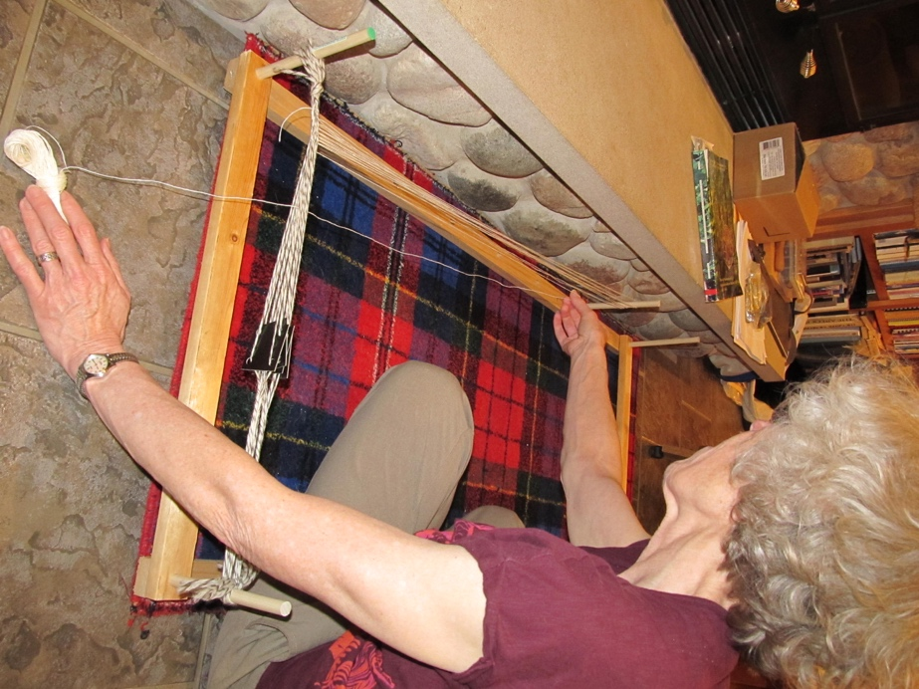
Figure 1. Warping board set up.

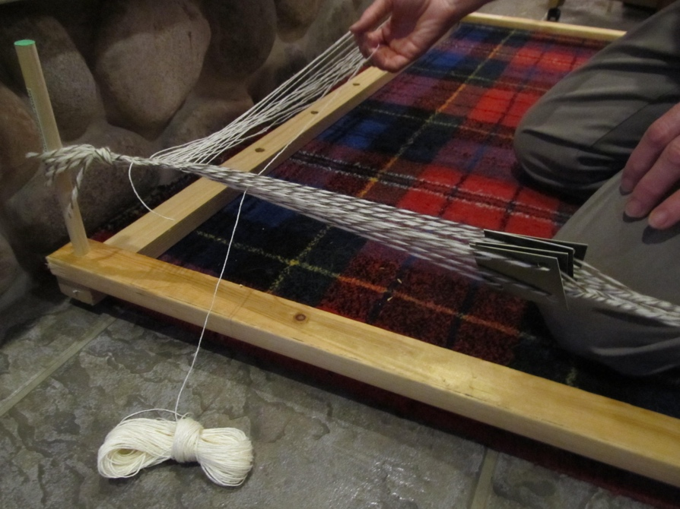
Figure 2. Pulling a loop through.

After you have tied the tablet warp in place, try turning the tablets to be sure they turn freely. Each quarter turn creates a new shed. Your warp for the final project must be in a ball or cone that dispenses yarn freely without tangling. Don’t worry if it looks bigger than the shed created by the tablets as you will NOT be bringing the entire ball of yarn through the shed. For each pick in the tablet weaving, you will bring a loop through the shed and around the appropriate peg(s) for the length you need. For our beginner piece, this will be about 1 yard. Turn the tablets a quarter turn and bring another loop through. It does not matter if you turn toward or away from you, but once you start keep going the same way until the threads are so twisted it is hard to weave and then just start turning in the opposite direction. When the warp threads are much thinner than the weft for the final project you can improve the spacing of the warps by using a small ball or butterfly of the weft which you bring through each pick along with the loop of warp. This thicker yarn goes back and forth through the tablet weaving only and does NOT go around the warp pegs. After trying to work without this supplemental tablet weft on my demo piece, I recommend that you use this method for your beginning piece even though it is not shown in the photos I took. It will make your piece somewhat wider than my sample and easier to weave due to better spacing of the warp threads. You should weave until you have 32 loops going around the warp pegs, work in the ends using a large needle, take the warp off the warping board and sew it onto the beam with the long threads hanging down. Keep the odd numbered threads in front of the shed bar and put the even numbered threads behind. Tie on 1 weight per 4 threads in two row, making two parallel rows one in front and one behind the shed bar.
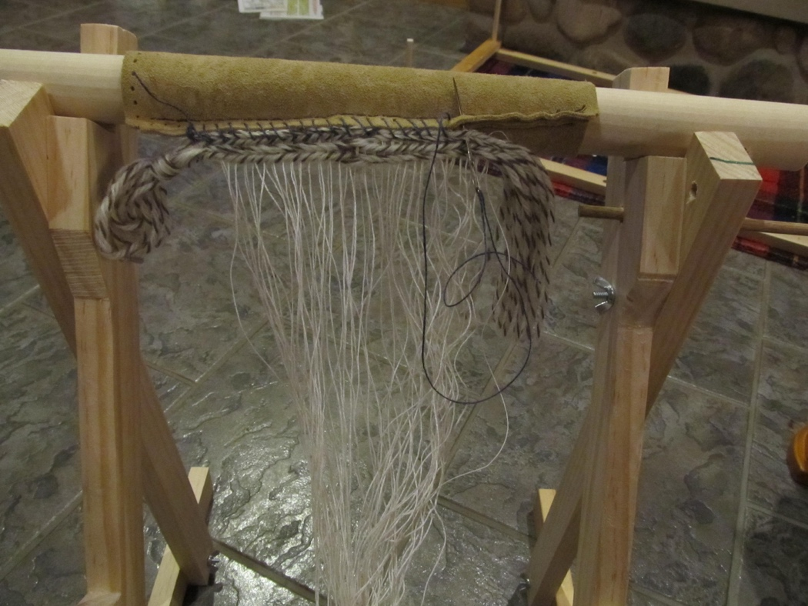
Figure 3. Sewing the warp to the beam.
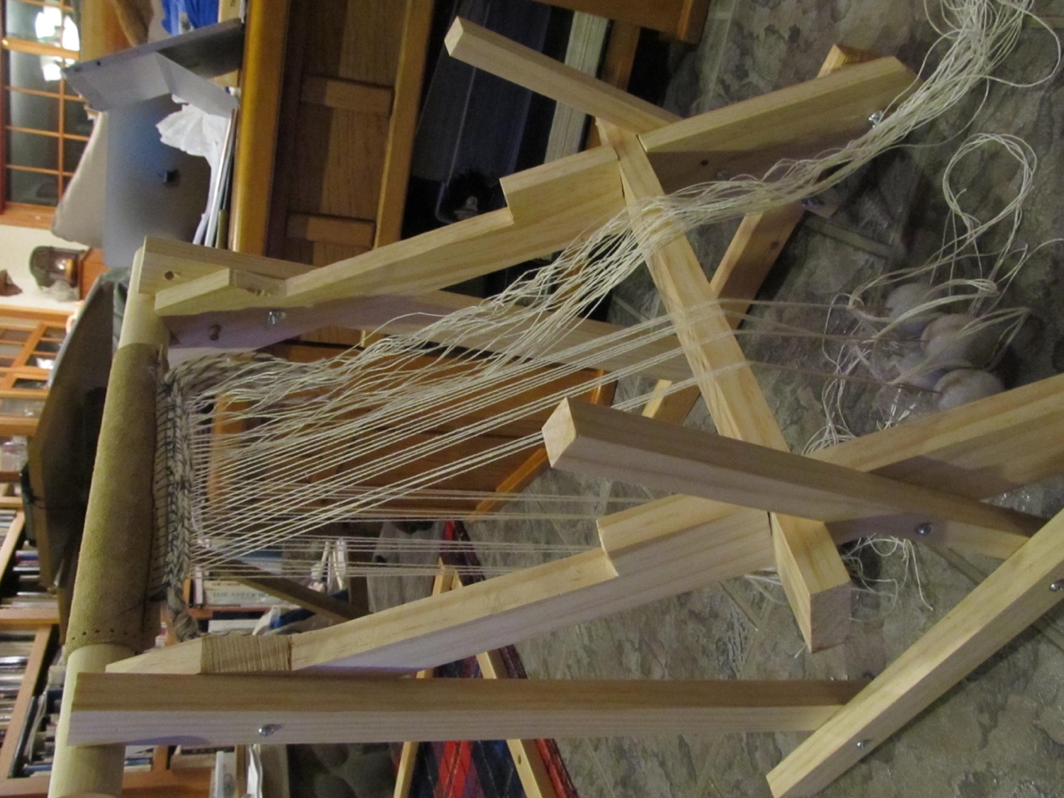
Figure 4. Tying on the weights.
Tying on the heddles
Place the heddle rod across the supporting notches. Take approximately 10 yards of strong thread or thin string and tie one end around the heddle rod. Bring the ball of heddle material backwards over the rod, around behind the rod, forward under the rod, and up through the loop making a buttonhole stitch. Anchor by making several buttonhole stitches in this way, then go backwards over the shed rod passing between the first two threads in front of the shed bar, catching the first thread in back of the shed bar, and returning between the same two front threads but below the shed bar and through the loop making a buttonhole stitch. Adjust the tension so that the thread you have caught is pulled slightly forward. Make the next buttonhole stitch around the heddle rod only, then one between the next 2 front threads catching the next back thread. After you have make several of these heddles, test the tension by moving the heddle rod over the top of the uprights to be sure the shed created is large enough to weave. Once you have the tension correct, continue making heddles in the same way until all the back threads have been caught and anchor with several buttonhole stitches around the rod only. Tie off. Test to make sure that the heddles pull alternate threads forward and that there is sufficient space to bring your warp through each shed.
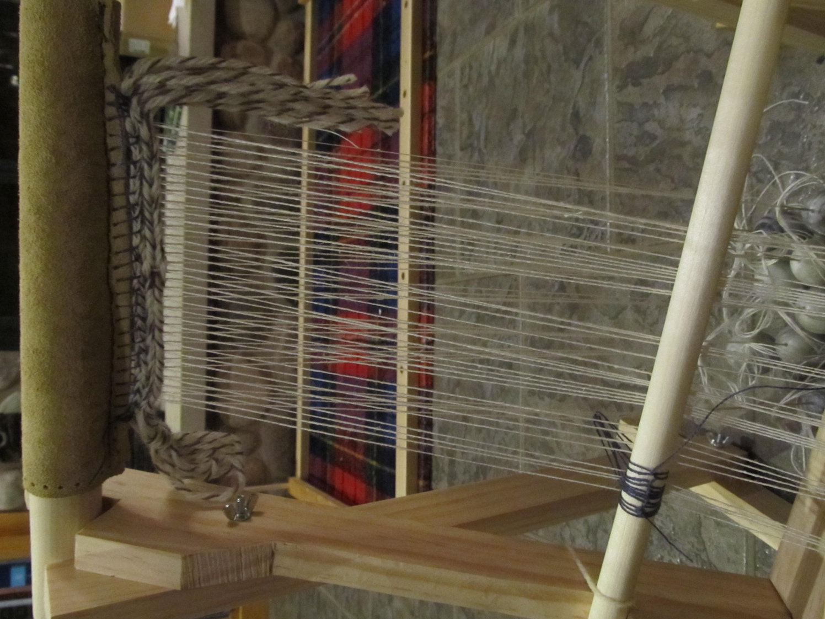
Figure 5. Tying on the heddles.
Chaining the warp
Take another piece of strong thread or light string about 5 loom widths and make a small loop about 1 foot from the end. Put this behind the front row of warp threads with the loop just to the left of the first warp thread. Put a crochet hook through the loop from front to back staying just to the right of the first warp, catch the string from the back and pull a loop through making a chain which now encloses the first front warp thread. Repeat across the entire front line of warp threads, and put the end through the last loop to lock it. Repeat with another string for the back row of warp threads.
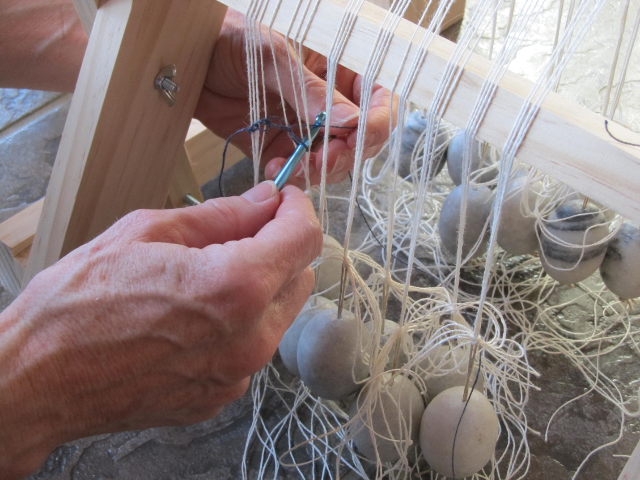
Figure 6. Chaining the front warps.
Starting to weave
Finally, you are ready to weave. Make a “butterfly” of warp yarn by winding a figure eight around your finger and thumb (left if you are right-handed). Continue wrapping until you have enough yarn to weave a couple of inches without stopping, then break off the yarn and wrap it around the center of your figure 8 tucking the end under the last couple of wraps. The starting end should now pull freely from the center of the butterfly. (If you have a stick shuttle of an appropriate size, you can use that instead). Now pull your heddle rod up and over the top of the vertical supports. Unwind from the INSIDE of your butterfly or unroll from your shuttle about 2 loom widths and bring the butterfly or shuttle through the shed allowing the trailing yarn to stay loosely in the shed. Use your fingers to push this weft thread toward the starting border. Lift the heddle rod back over the vertical supports and place it back in the notches. Beat the weft upwards with a flat stick or the side of your hand placed in the new shed, then put your weft through the same shed. Continue this way making sure the weft is not drawing the warp threads in from the sides. When you run out of weft yarn, join a new one by overlapping the old and the new by at least 6-8 warp threads. Just let the ends fall to the back. You can work them in later. When the weaving moves down toward the heddle rods, eventually the sheds will get too narrow. That means it is time to roll the woven cloth around the beam. It is held by a dowel through the beam which is stopped by a dowel at right angles through the top of the upright. This may cause the weights to be too high, in which case you just untie and retie them lower. Don’t forget to gently work the chaining cord down or it may obstruct your weaving.
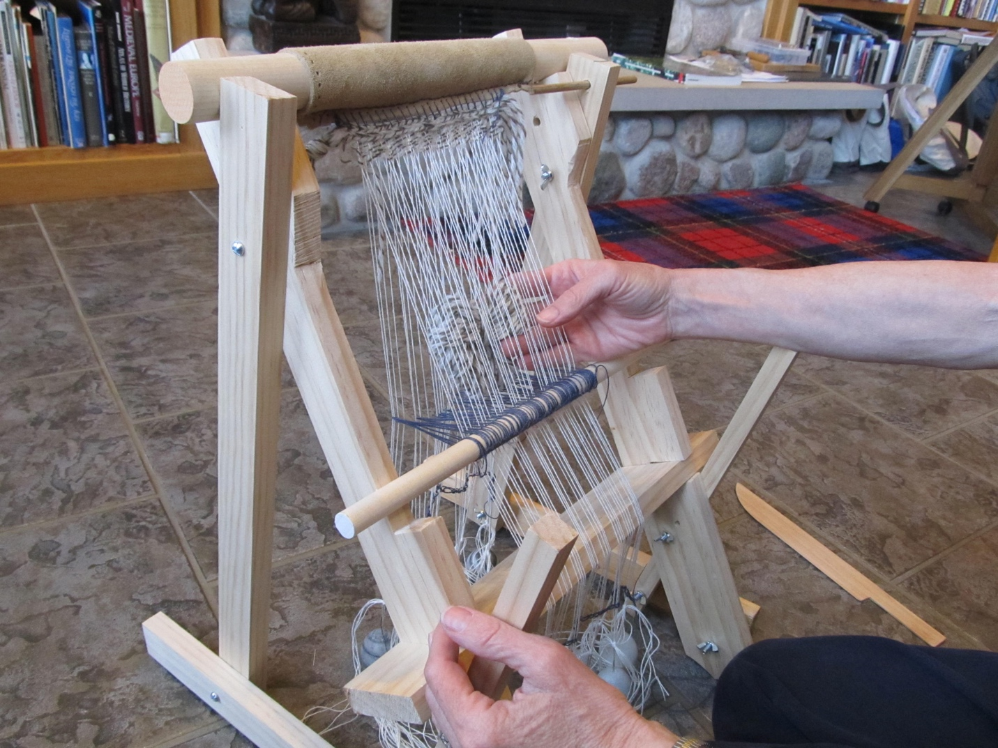
Figure 7. Weaving the natural shed.

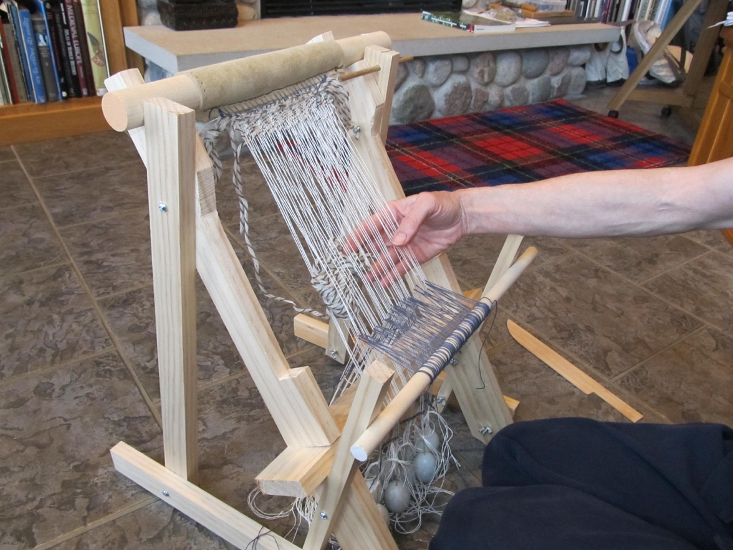
Figure 8. Weaving the heddle bar shed.
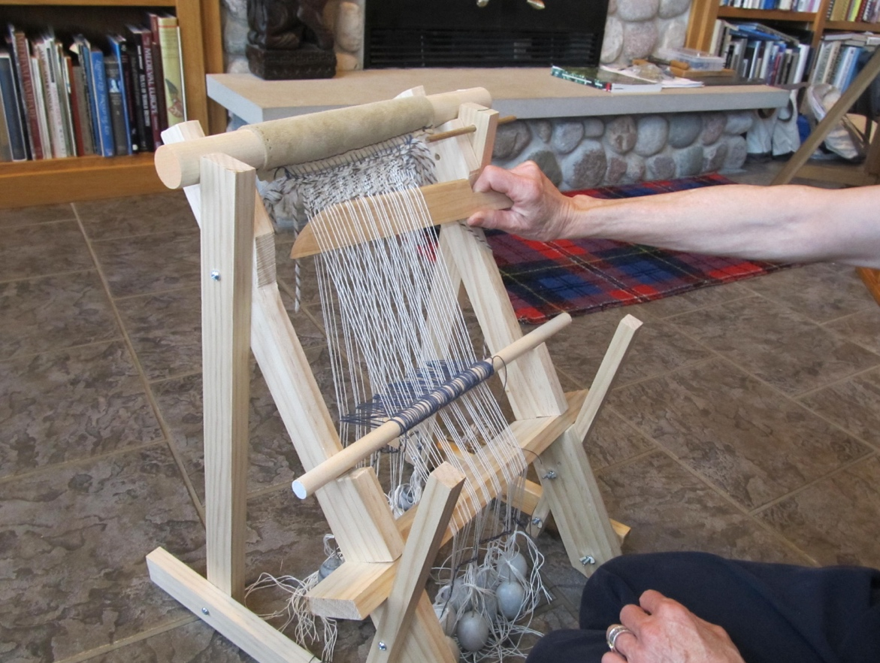
Figure 9. Beating.
Finishing
When your weaving is long enough (about 18 inches for a cap or twice the depth you want for a bag) you are ready to make the finishing border. Roll the work so the bottom edge is approximately even with the top of the vertical heddle supports. Make a tablet weaving warp with 4 tablets alternately S and Z threaded just as at the beginning, but this time tie it to the ends of the upright heddle supports. If you used a thick yarn weft along with the warp threads for the top, you will want to do it the same way now. Leaving the weights on, cut the first warp thread about 3 inches below the level of the tablet warp and use it as a weft in the tablets bringing it down through the shed created by the cards. Make a quarter turn of the tablets, cut another thread and bring it down through the new shed. Also bring the first thread back up through the same shed so the loose end is now toward the top of the loom. As you continue cutting one thread at a time you will have a row of loose ends pointing upwards, but you should have only one downward pointing thread at a time. Don’t worry if the tablet woven border does not quite snug up to the bottom of your weaving. You can tighten it up later by pulling on the free ends. When all the warps have been cut off and used you will have all the loose ends pointing upwards. Pull them to adjust the border and then trim them off. Fold you work crosswise so the two tablet woven borders are together. Sew one edge if you want a cap or both edges for a bag, add ties for a cap and a strap for a bag. You have now made your first tablet woven item.
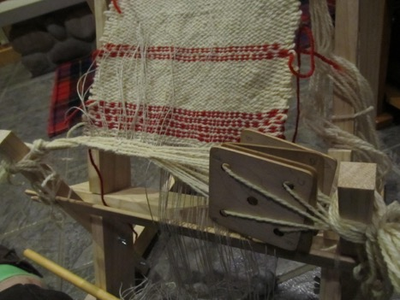
Figure 10. Weaving the bottom boarder.

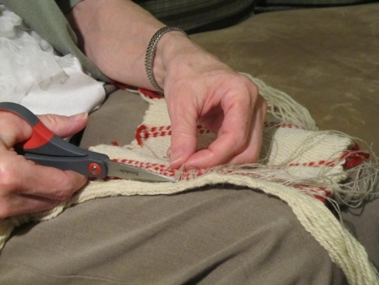
Figure 11. Trimming the warp ends.

Ealasaid nic Phearsoinn (mka Elspeth Christianson)
Ealasaid27@gmail.com

